**QwikLab: Intro to S3**

Time spent: 60 min

**What is AWS S3**

Amazon Simple Storage Service is a "simple storage service" offered by AWS that provides object storage through a web service interface.

What I learned:  
1. How to create the bucket

Because all the object are stored in buckets on S3

1. Click S3
2. Click create the bucket
3. Finish the configuration

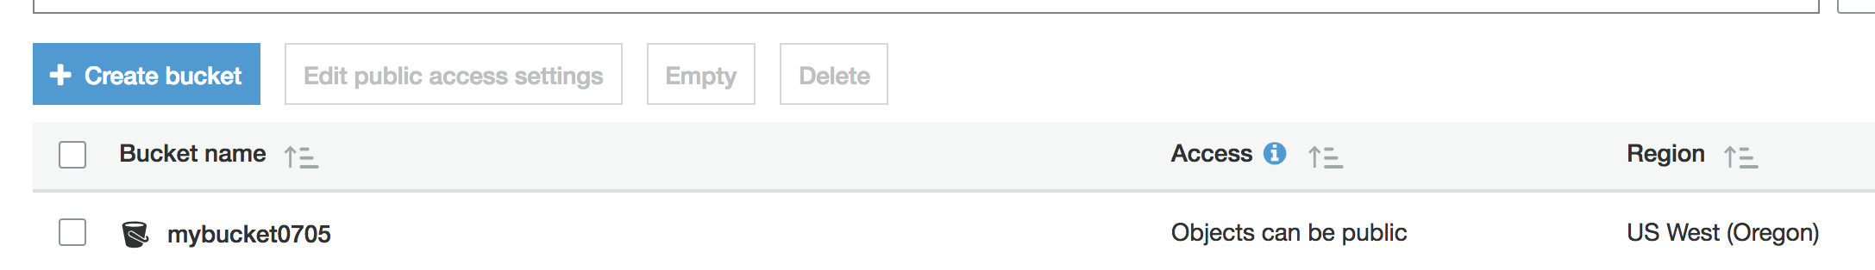

2. How to upload the object to the bucket

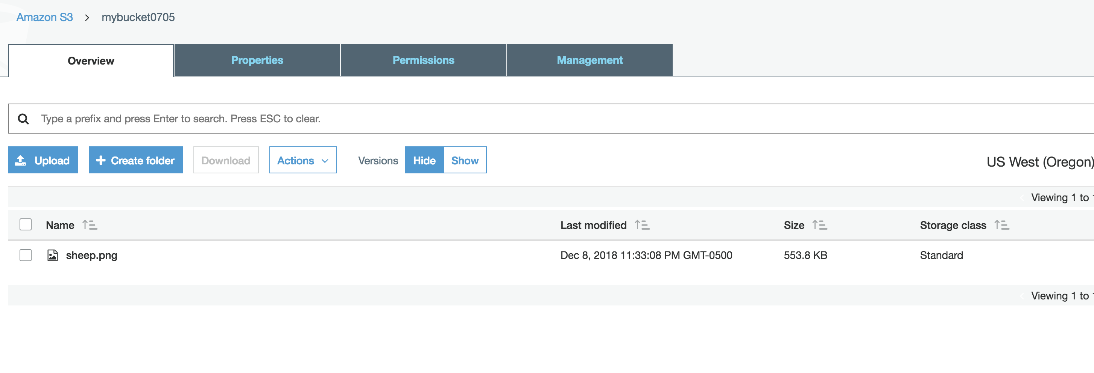3. How to make the object public

If it is private

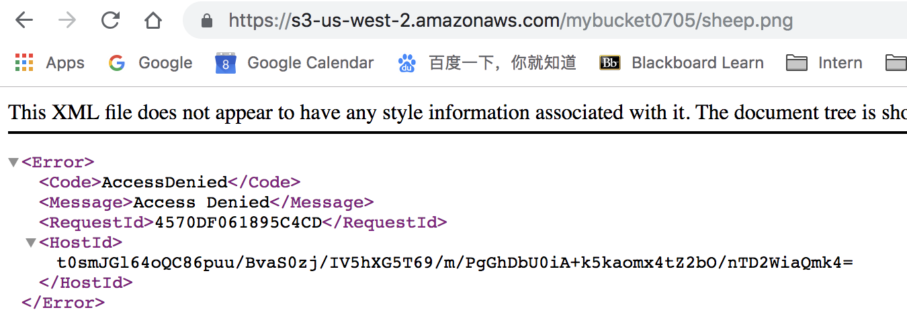

But if I make it public

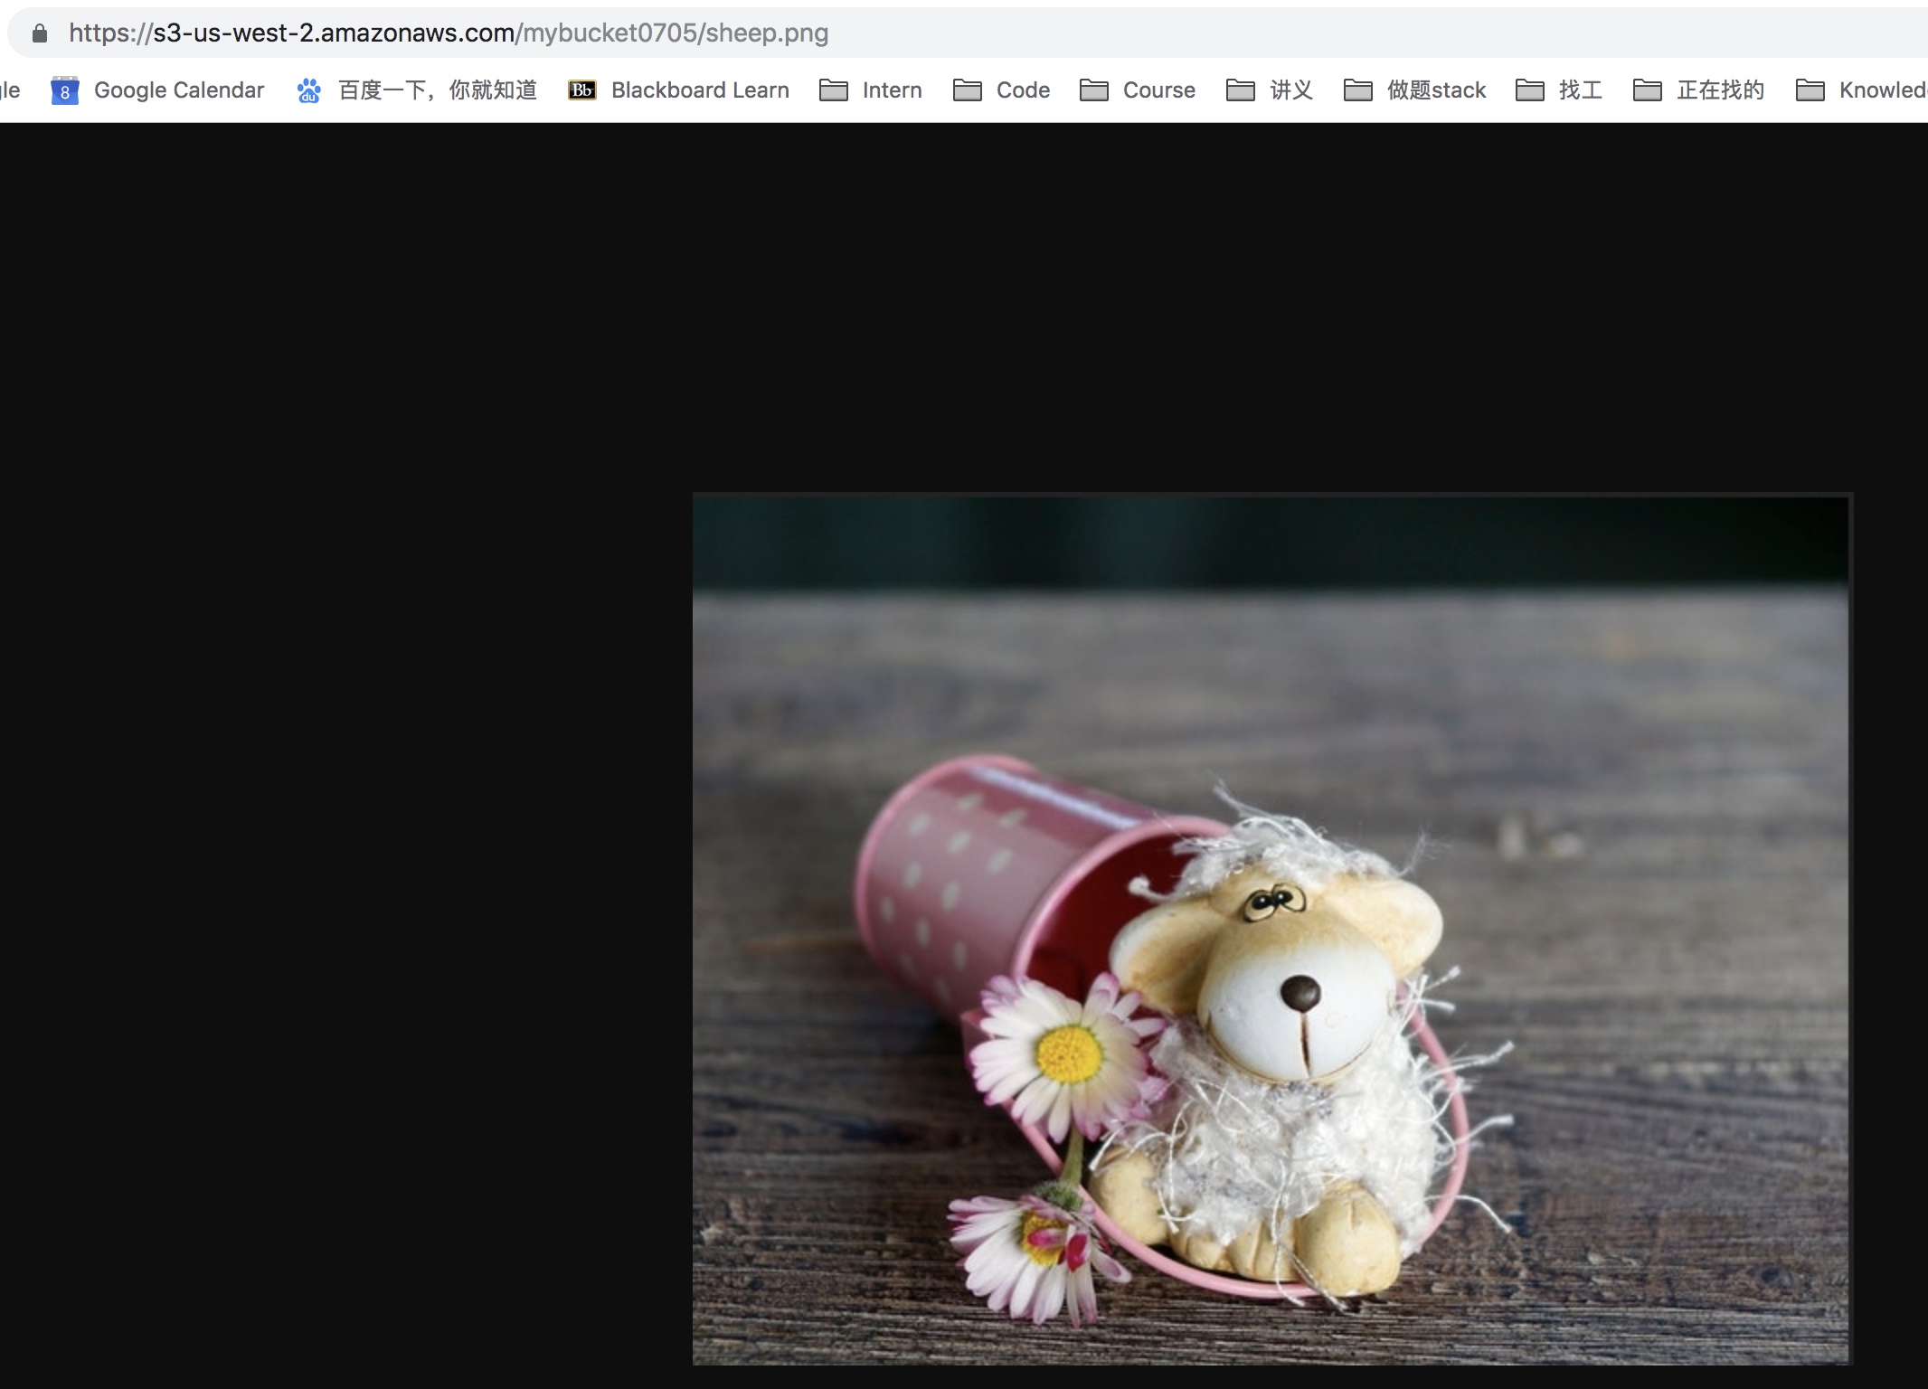

4. How to create Bucket policy

Use policy generator, select action and ARN, then get the JSON

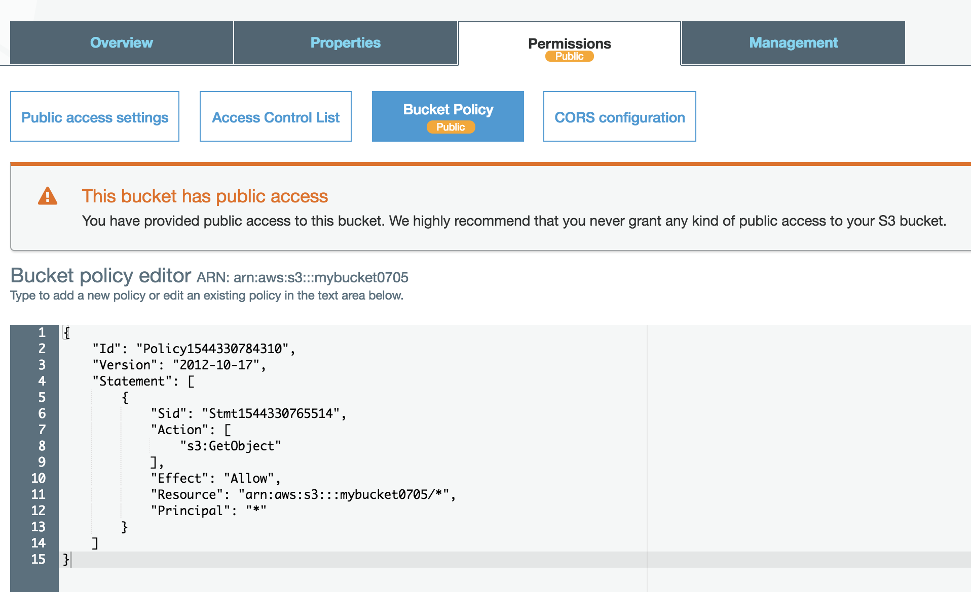



5. How to explore the version

The object version in the bucket likes the version control, which is really important.



Old version:

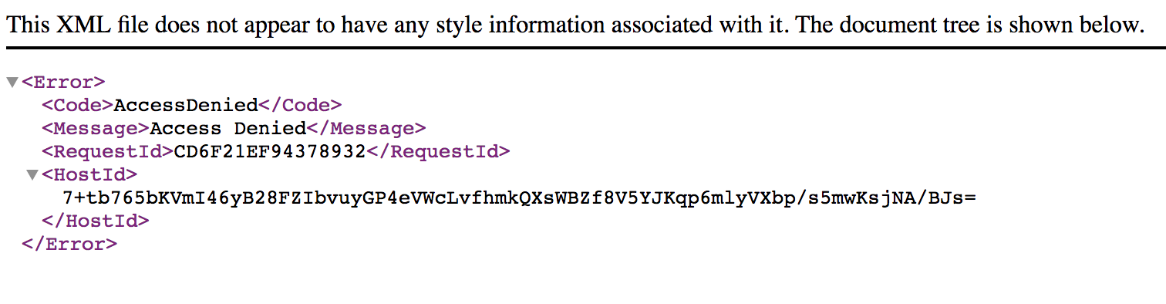

After change policy:



**Summary:**

In this Lab, I have learned how to use the AWS S3 and basic S3 storage function, access policy.